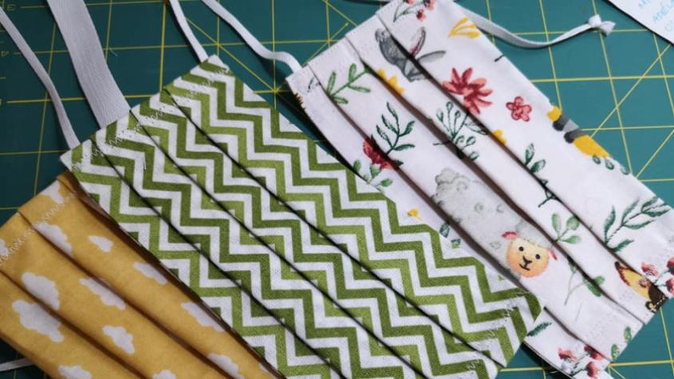

My face mask protects you,

your face mask protects me.

Johana H. | 1.E | 25.3.2020

Face mask
In the Czech Republic, there is crisis of surgical masks, because of coronavirus, as we know. But thank God our citizens are thoughtful and they are not scared to help someone else. They have made a lot of homemade face masks. For example from an old T-shirt or some other pieces of cloth. Face mask or any kind of a mask which protects you and other people is so important in this period. I mean in the case of the emergency state. Actually, this mask can be made from any cloth, or it can be your scarf as well. We have this crisis because the whole world is dependent on China. Chinese make around 20 million masks per day. Recently they have increased production 5 times, that is around 100 million masks a day. That is insane, isn’t it? But it is still not enough to satisfy the global demand.
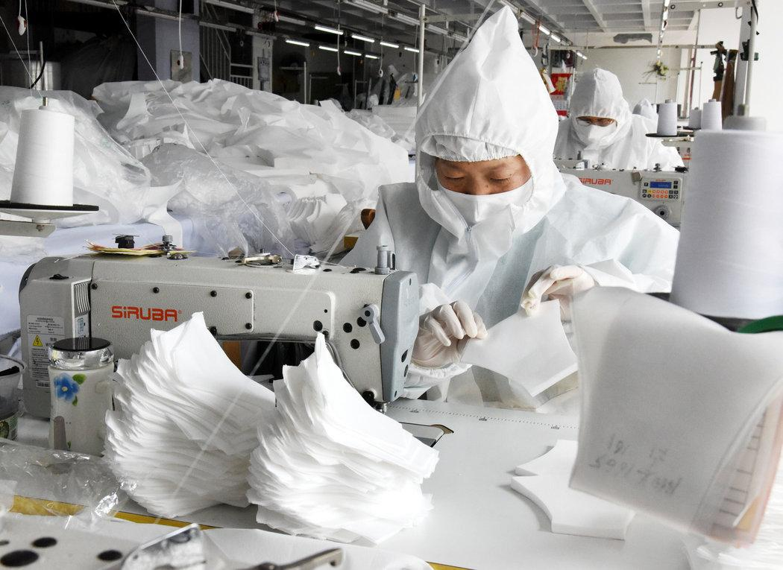
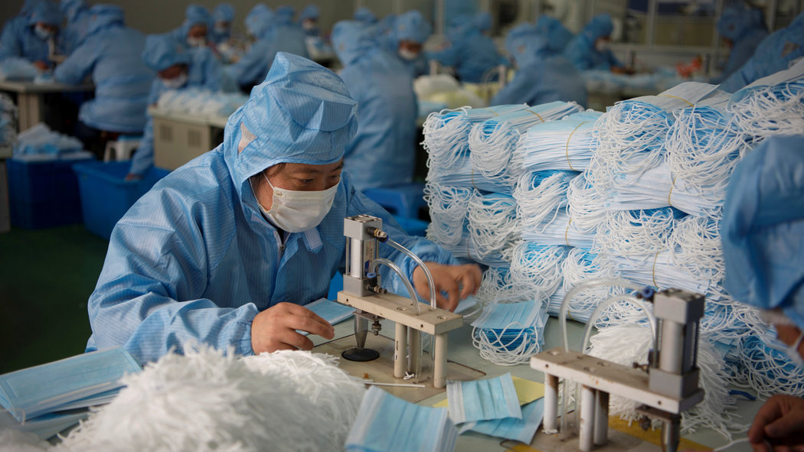
Manufacture of masks in China
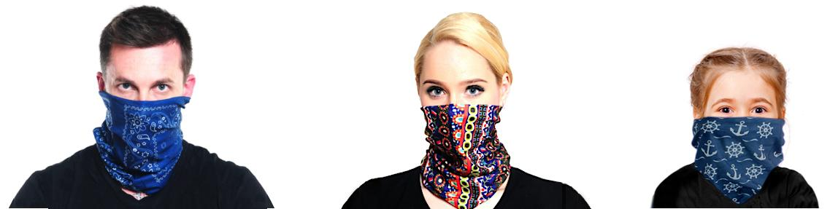

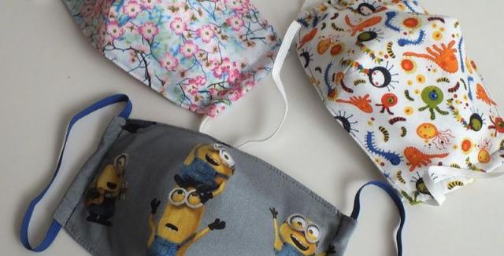

Seniors
Look at the doctors and nurses, they work day and night for us, they have a minimal rest. We can help them, just a little bit, but every help counts. We can make masks for our family, friends. But what about seniors? If you think that someone else is helping them so you don’t have to help them, you are wrong. People have helped them, but there are a lot of seniors and those people can’t help everyone. You can at least go shopping for them and make masks for them. Most of them need to visit a doctor and they don’t drive so they have to go by bus. When there is on the bus someone who doesn’t have a mask and can be infected, seniors catch it easier than other people. So in order to protect them, to protect ourselves and other people, you will see that you are not alone who does something. There are a lot of people who wear masks and it is not a shame. It is a heroism, it is manifestation of love to others, it is one of the most beautiful things when you see how people protect other people and help them. Then think about Italy, the country with the second oldest population in the world (the first one is Japan). And that is why they have the highest number of deaths.
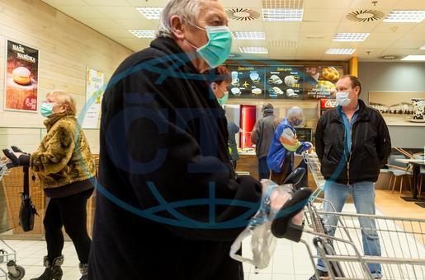

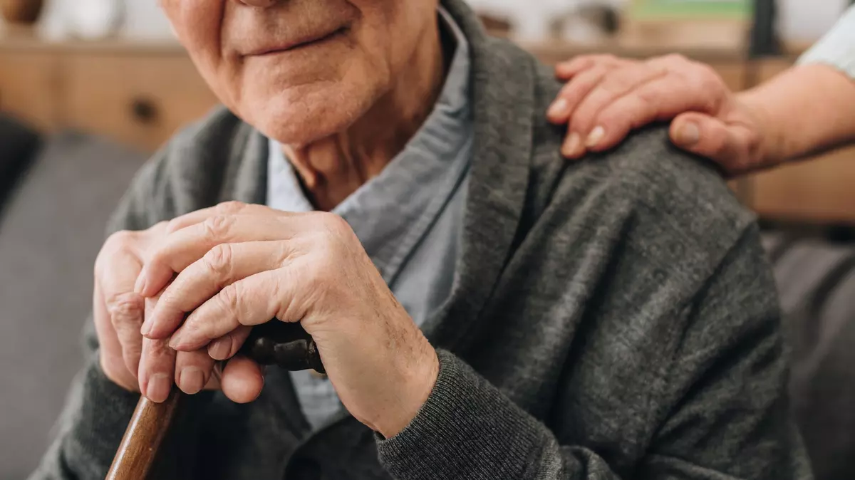

Crisis of surgical masks in the world
We are not alone in this crisis, crisis of surgical or any kind of masks exists in the world too. For example in France, Germany, Italy, Netherlands. In France, there were several cases, when people have stolen around 8 300 surgical masks in Paris and around 2000 in Marseille. In Slovakia they have only around 1.23% necessary masks in pharmacies. In Norway, they have the same problems. In French hospitals they have no protective equipment at all.
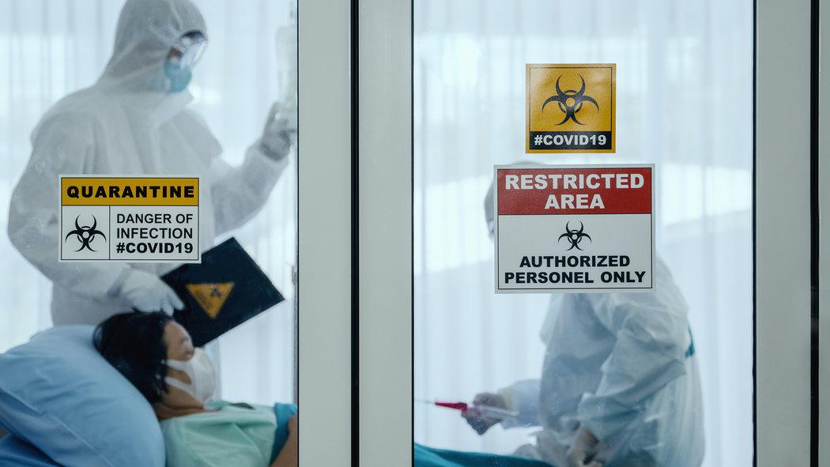

Problem with Berlin
A lot of European states have problem with Berlin, because the German government confiscated every surgical mask, which travelled to other states. Belgium became a victim of fraud, when the Belgian government ordered a shipment, which cost 5 million €.

And what is the result?
We have discovered we live in the world full of solidarity, friendship, support and help and I am sure this is the most relevant positive message we are receiving during this world crisis. Many people will lose their jobs, the standard of living may change in many cases, but at the end of the day, what counts is love, friendship and family!

WE WILL SURVIVE

